Project Design Phase-II
Data Flow Diagram & User Stories

Date | 28 September 2026
Team ID | 6ab227b1fc67a5bc02225fe4
Project Name | UNM110AI_BlogNest
Maximum Marks | 4 Marks

Data Flow Diagrams:
A Data Flow Diagram (DFD) is a traditional visual representation of the information flows within a system. A neat and clear DFD can depict the right amount of the system requirement graphically. It shows how data enters and leaves the system, what changes the information, and where data is stored.

Example: (Simplified)



User Stories
Use the below template to list all the user stories for the product.
User Type | Functional Requirement (Epic) | User Story Number | User Story / Task | Acceptance criteria | Priority | Release
Customer (Mobile user) | Registration | USN-1 | As a user, I can register for the application by entering my email, password, and confirming my password. | I can access my account / dashboard | High | Sprint-1
 |  | USN-2 | As a user, I will receive confirmation email once I have registered for the application | I can receive confirmation email & click confirm | High | Sprint-1
 |  | USN-3 | As a user, I can register for the application through Facebook | I can register & access the dashboard with Facebook Login | Low | Sprint-2
 |  | USN-4 | As a user, I can register for the application through Gmail |  | Medium | Sprint-1
 | Login | USN-5 | As a user, I can log into the application by entering email & password |  | High | Sprint-1
 | Dashboard
Customer (Web user)
Customer Care Executive
Administrator

AI BlogNest — Data Flow Diagram
Level 0: Visitor/User → React Web Application → Express REST API → MongoDB. Authenticated AI operations additionally flow from the API to Google Gemini and back.
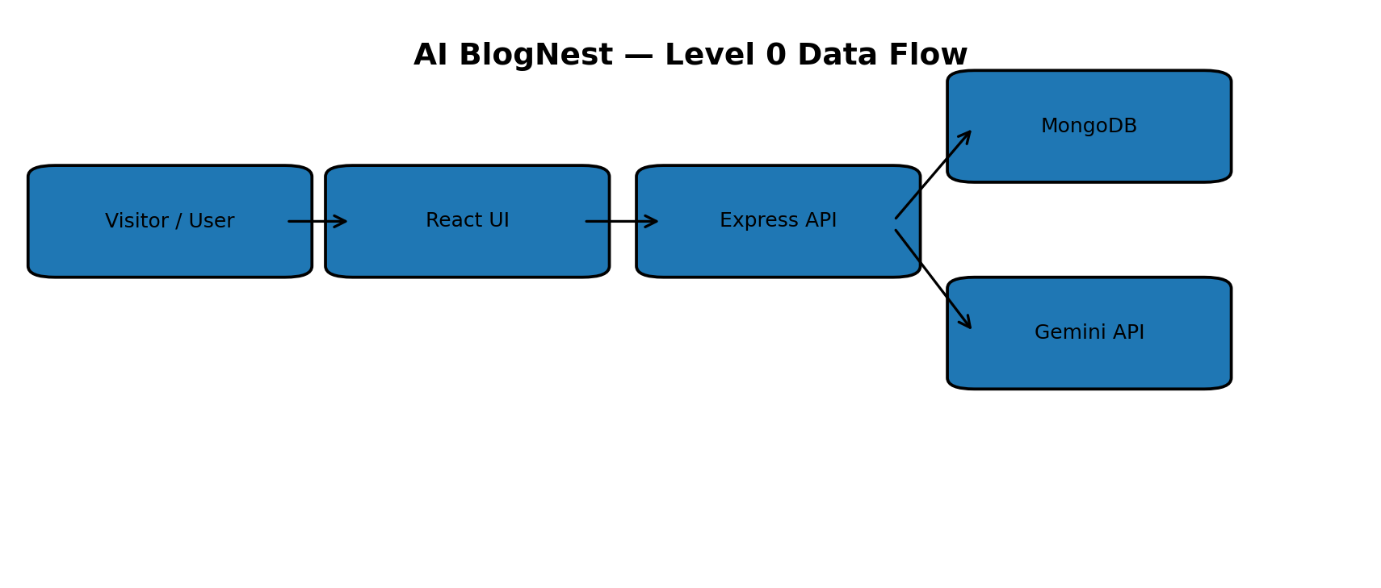
Figure 1: Level-0 data flow

User Stories
User Type | Functional Requirement (Epic) | User Story Number | User Story / Task | Acceptance criteria | Priority | Release
Visitor | Public Discovery | USN-1 | As a visitor, I can view published stories. | Stories are displayed. | High | Sprint-1
Visitor | Public Discovery | USN-2 | As a visitor, I can open an individual story. | Valid blog detail loads. | High | Sprint-2
Reader | Discovery | USN-3 | As a reader, I can search by title, content or author. | Matching stories remain. | High | Sprint-3
Reader | Discovery | USN-4 | As a reader, I can filter by category. | Selected category applies. | Medium | Sprint-3
Reader | AI Summary | USN-5 | As a reader, I can summarize content with AI. | Summary is returned or error shown. | High | Sprint-4
User | Registration | USN-6 | As a user, I can register. | Account is created after validation. | High | Sprint-1
User | Login | USN-7 | As a user, I can log in. | JWT is returned. | High | Sprint-1
User | Profile | USN-8 | As a user, I can access my profile securely. | Valid JWT returns profile. | High | Sprint-1
User | Blog Management | USN-9 | As a user, I can create and publish a story. | Blog is saved with current author. | High | Sprint-2
User | Blog Management | USN-10 | As a user, I can edit my own story. | Owner can update fields. | High | Sprint-2
User | Blog Management | USN-11 | As a user, I can delete my own story. | Owner can delete it. | High | Sprint-2
User | AI Studio | USN-12 | As a user, I can generate a blog from a topic. | Gemini draft is cleaned and saved. | High | Sprint-4

